1. What is SNS ?   
It is a web service that makes it easy to – set up, operate, and send notifications from the cloud.  
  
It provides developers with a highly scalable , flexible, and cost-effective capability to publish messages from an application and immediately deliver them to subscribers or other applications.  
  
You have push notifications to Apple, Google, FireOS and Windows Devices, Android devices.  
  
Besides pushing cloud notifications to mobile devices, we can use Amazon SNS to deliver notifications by SMS text message or email to SQS queues or to any http endpoint.  
  
SNS notifications can also trigger lambda functions, When a message is published to a SNS topic, that has a lambda function subscribed to it, The lambda function is invoked with the payload of the published message.

2. SNS Topic

SNS allows you to group multiple recipients using topics.  
A topic is an ‘access point’ for allowing different recipients to dynamically subscribe for identical copies of the same notification.

One topic can support deliveries to multiple endpoint types.  
For Example : You can group together IOS, Android, SMS recipients.  
When you publish a message once to a topic, SNS is going to deliver the ‘appropriately formatted’ copies of your message to each subscriber.

3. Lost messages ? : To prevent messages from being lost all messages published to SNS are stored redundantly across multiple availability zones.

4. SNS Benefits.  
- Instantaneous push based delivery – no polling required.  
- Simple APIs and easy integration with applications.  
- Flexible message delivery over multiple transport protocols – https/text/push notifications to mobiles.  
- Inexpensive pay-as-you-go model.

5. SNS pricing.  
User pays $50 cents per 1 million amazon SNS requests.  
User pays 6 cents per 1 lakh Notification deliveries over http.  
User pays 75 cents per 100 Notification deliveries over SMS.  
User Pays $2 per 1Lakh Notification deliveries over email.

6. pub-sub.  
AWS SNS follows the pub-sub messaging paradigm., With notifications being delivered to clients using a ‘push’ mechanism that eliminates the need to periodically check or poll for new info.  
  
7. LAB : Topic and its subscriptions.  
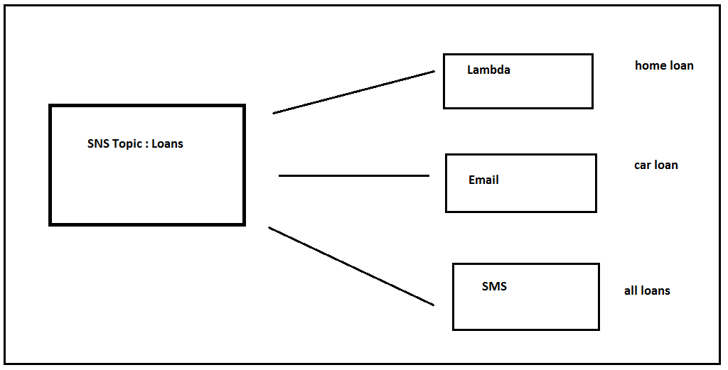  
  
Any time a message comes to a topic, It goes to all the subscriptions in the above case – Lambda / Email / SMS. That’s why SNS message filtering comes into play.  
  
SNS Message Filtering : With SNS message filtering we can selectively trigger each subscription based on a message.

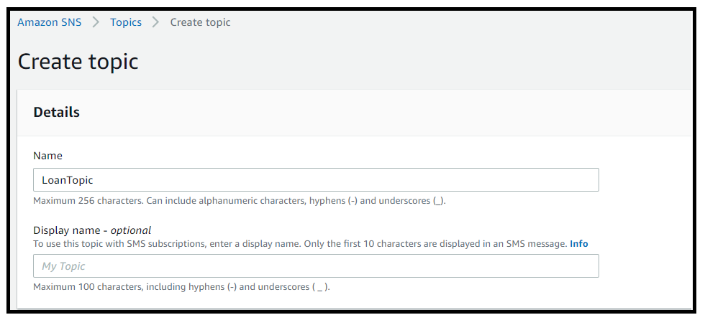  
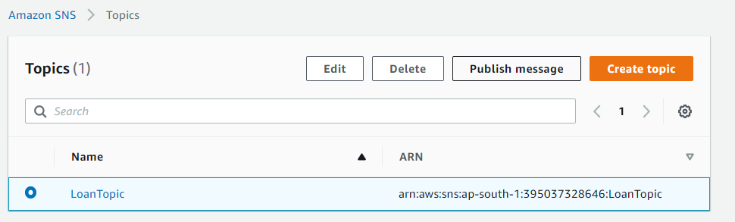  
  
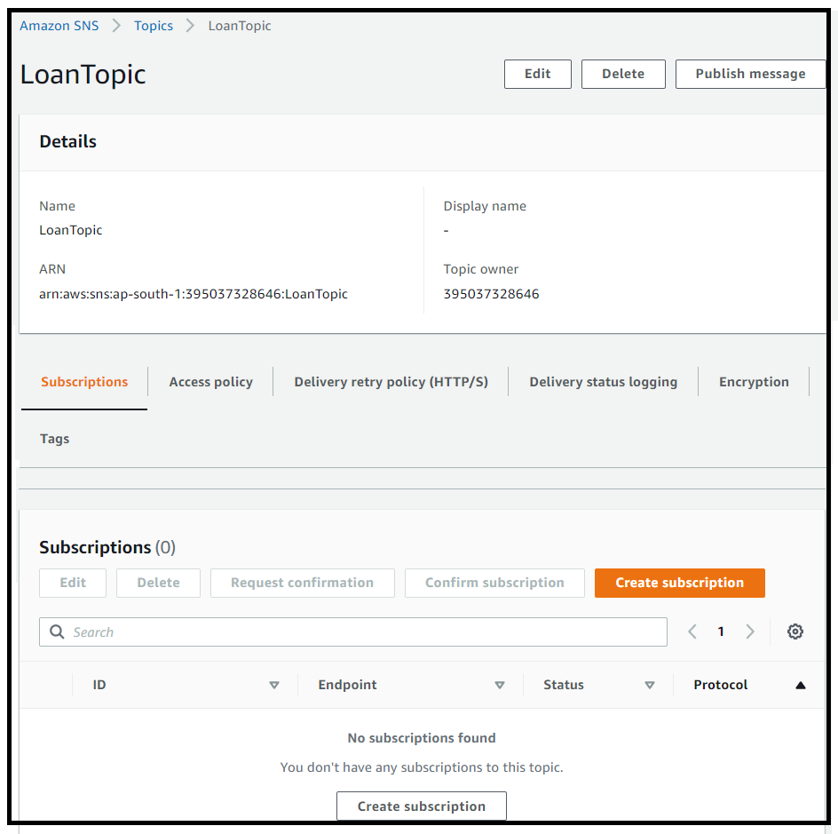  
  
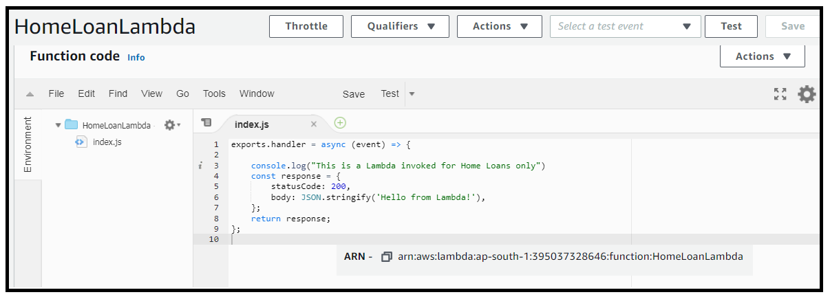  
  
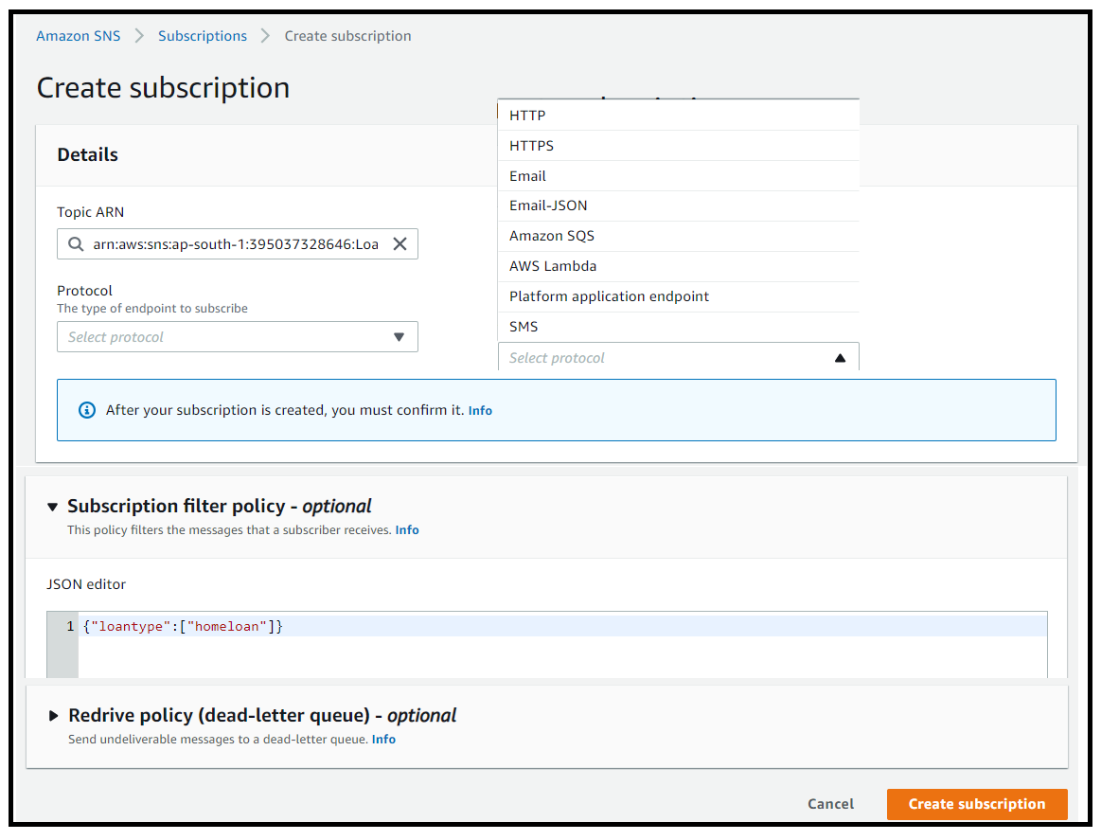  
  
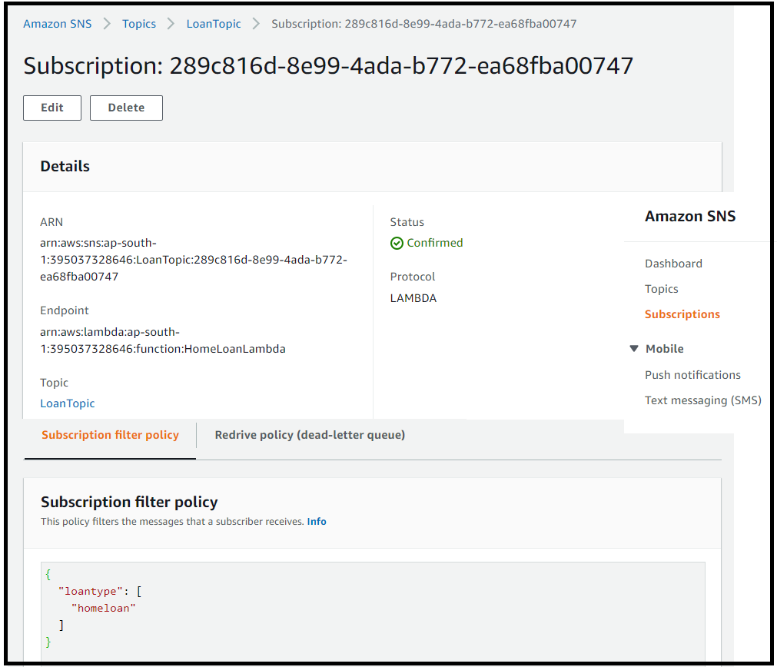  
  
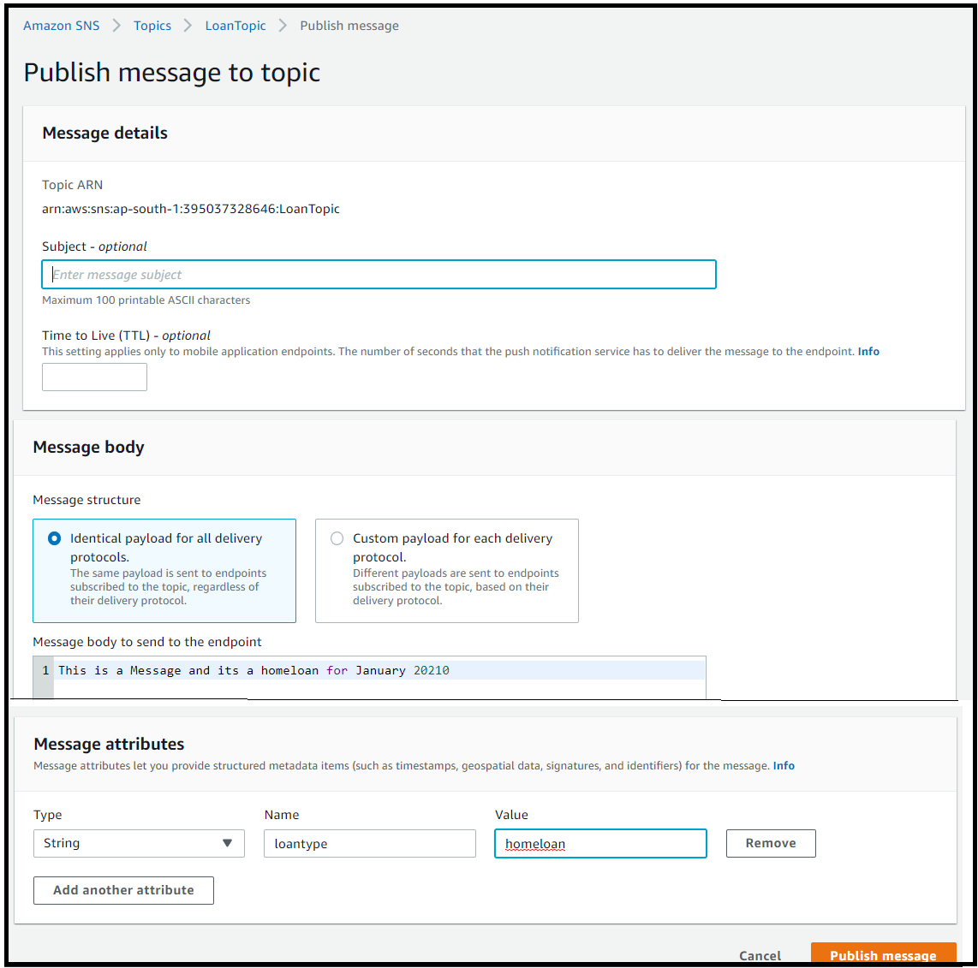  
  
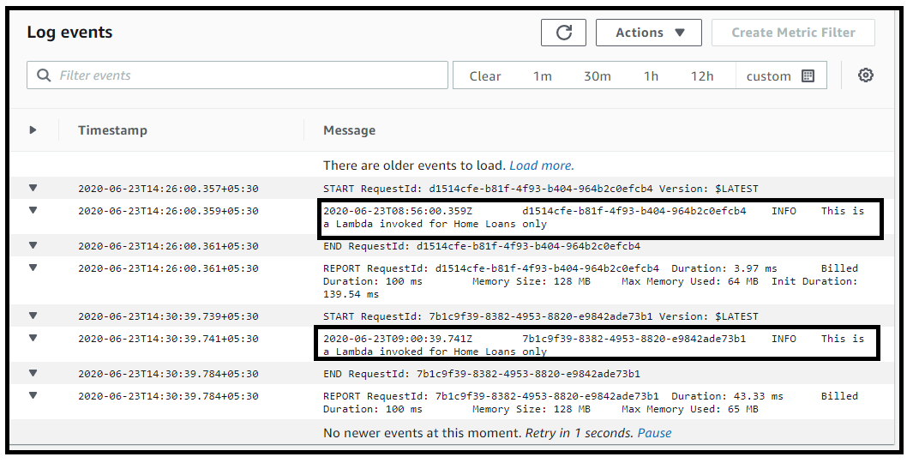  
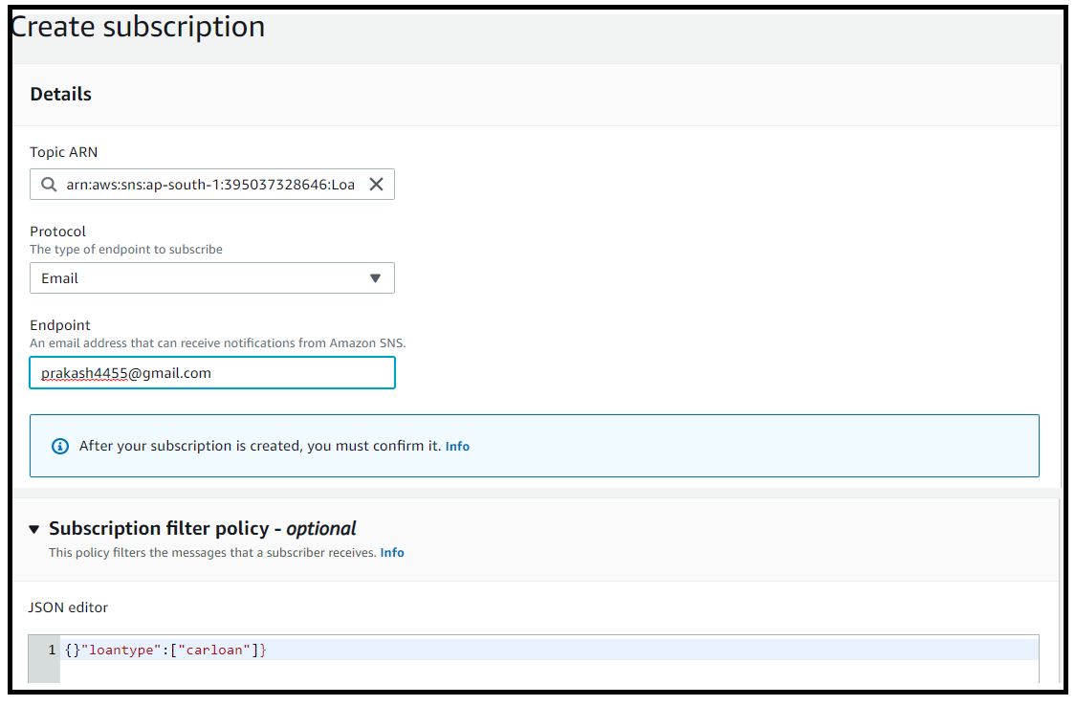  
  
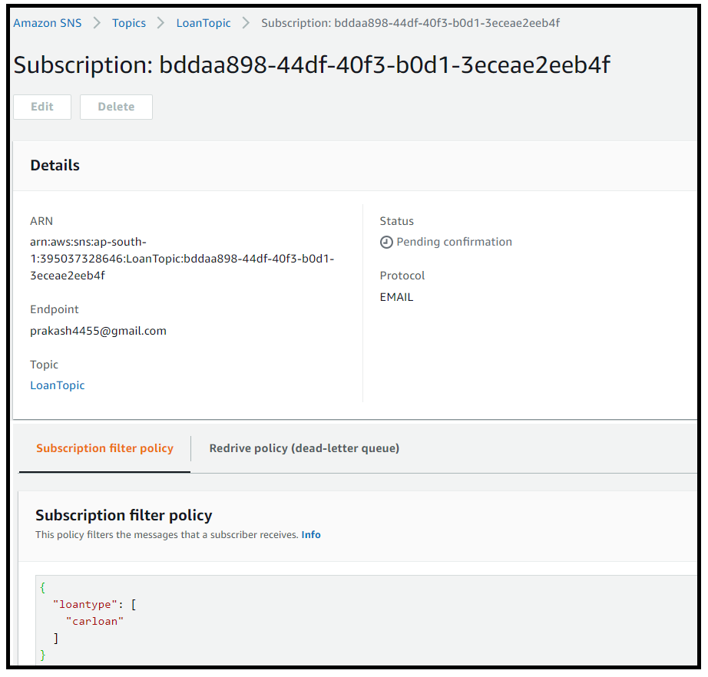  
  
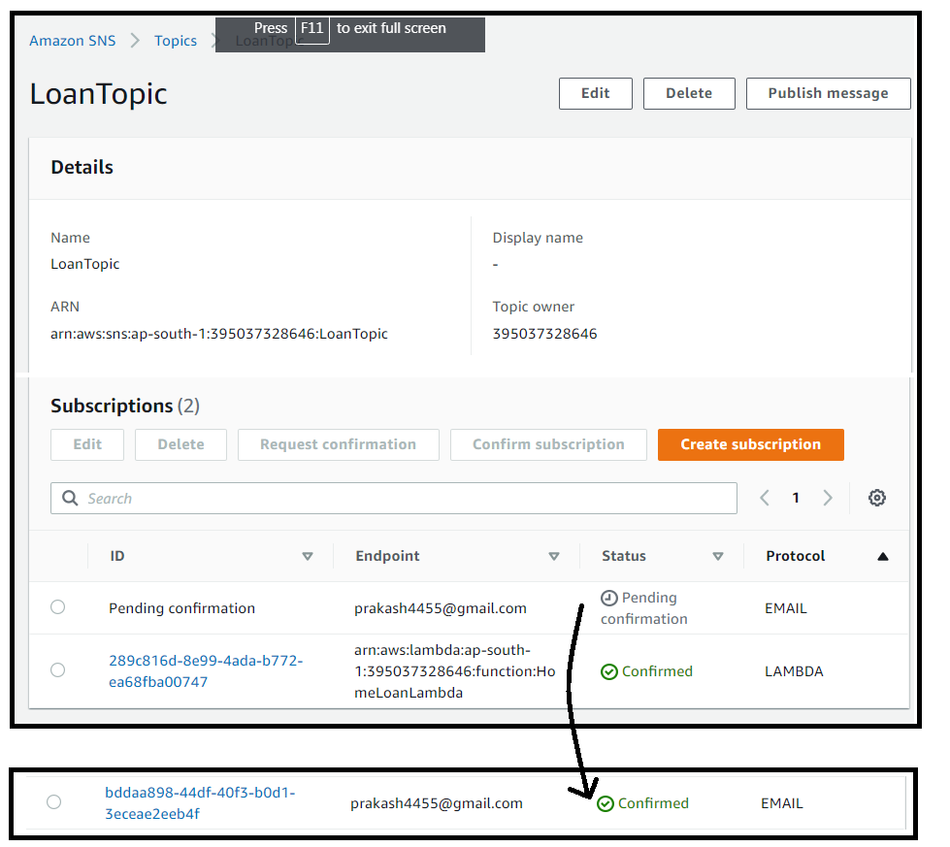  
  
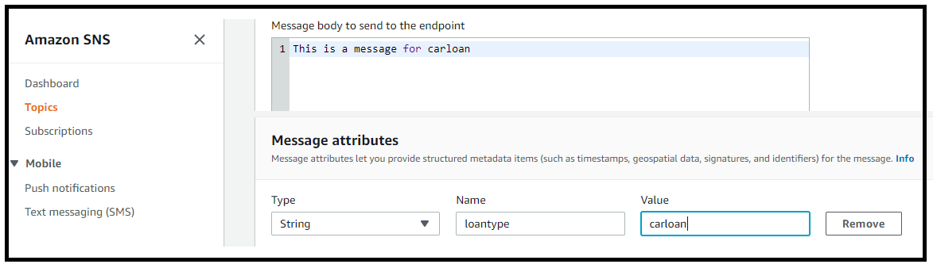  
  
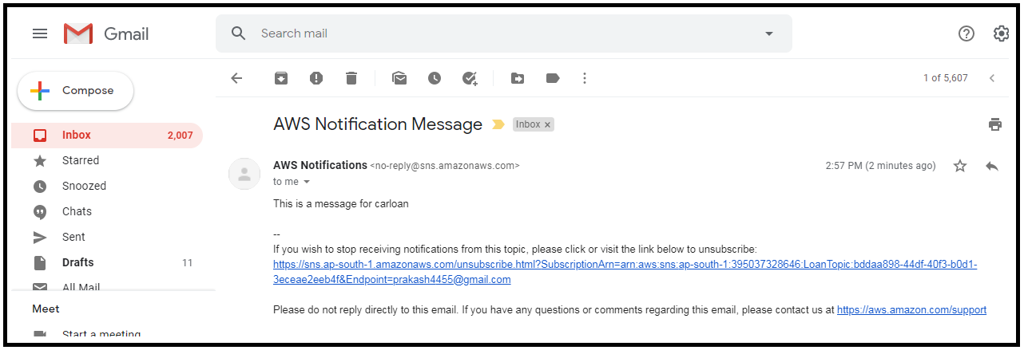  
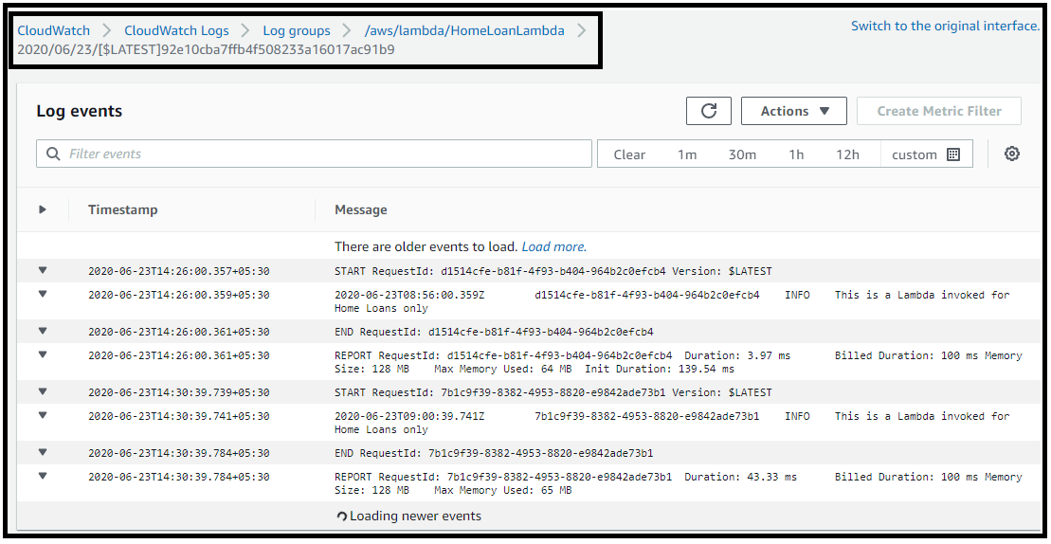  
  
If the event in the lambda is printed-   
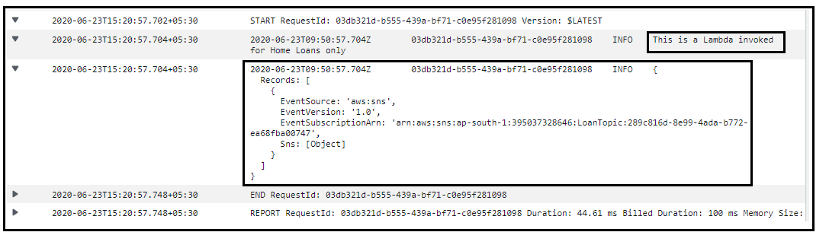  
  
8. LAB -2   
Send SNS notification using python code.  
Install Python.  
Install AWS CLI for windows.  
Install Visual Studio code.  
